A REPORT ON

Service Reliability and Role of AVL in transportation system

BY --- SANDESH SAXENA

A report on

Service Reliability and Role of AVL in transportation system

Submitted to
Fabian Cevallos ,Ph.D.
Transit Program Director
Lehman center for transportation Research(LCTR)
Florida International University
( U.S.A )

Submitted by
Sandesh Saxena
Research Scholar
(Department of Civil Engineering )
Anand International College Of Engineerring
( INDIA )

JULY 2013

COPYRIGHT NOTICE



All rights reserved. No part of this document may be reproduced or transmitted in any form or by any means, electronic, mechanical, photocopying, recording, or otherwise, without prior written permission of institution Name.

ACKNOWLEDGEMENT

I have taken efforts in this project. However, it would not have been possible without the kind support and help of many individuals and organizations. I would like to extend my sincere thanks to all of them.

I am highly indebted to Prof. Fabian Cevallos, for their guidance and constant supervision as well as for providing necessary information regarding the project & also for their support in completing the project.
I would like to express my gratitude towards my parents & member of college for their kind co-operation and encouragement which help me in completion of this project.

I would like to express my special gratitude and thanks to Florida International University’s persons for giving me such attention and time.

My thanks and appreciations also go to my colleague in developing the project and people who have willingly helped me out with their abilities.

SANDESH SAXENA

Table of Contents
- COVER PAGE…………………………………….………………………………1
- COPYRIGHT NOTICE…………………………….……………………………..2
- ACHKNOWLEDGEMENT……………………………………………………….3
- TABLE OF CONTENTS……………………………….…………………………4
1. Introduction …………………………………………………..………………………6
2. Service reliability …………………………………………….………………………7
2.1 Components of service reliability …………………………………………..7
2.2 Performanceand reliability in Public Transport ……………………………9
3. Automatic Vehicle Location (AVL)………………………………......................10
3.1 Introduction and architecture of AVL ………………………………………10
3.2 Mechanism of AVL ……………………………………………………………12
3.3 Application of AVL systems - iBus system……………………………….13
3.3.1 How iBus works………………………………………………………….13
3.3.2. Real-time passenger information……………………………………..16
3.3.3. Fleet management and operations (FMOs)………………………….16
3.3.4 Bus priority at traffic signals…………………………………………..16

4. Data architecture and post processing applications…………………………18

4.1 Improved bus service monitoring…………………………………………….19

4.2 Enhanced operational reporting/scheduling………………………………..20

4.3 Spatio-temporal analysis………………………………………………………21

4.4 Dwell time estimation…………………………………………………………..21

4.5 Bus performance analysis for bus priority………………………………….23

5. AVL data and its flow ……………………………………………………………. 25
5.1 Database Storage……………………………………………………………..26
5.2 Mapping the Network Drive………………………..…………………………27
5.3 Database Description………………………..………………………………..29
5.3.1 ADHSUM Table……………………………………………………..…30
5.3.2 Queries……………………………………………….………………...32
5.3.3 Reports……………………………………………….………………..37
6. Conclusion …………………………………………………………………………..39
- Appendix A………………………………………………………………………40
- Refrences ……………………………………………………………..…………43
1. Introduction
Service reliability is ‘keeping the transit vehicle on schedule, with uniform headways and a consistent travel time’. In 2001 Kimple said, ‘Transit service reliability is a multidimensional phenomenon, no single measure that can adequately address service quality”.
Service reliability is described by different parameters either based on transport user or based on transits agencies.In this techno world things are moving on to the compute based technologies which uses some assembly (section 3.1). The resent computed based technology is AVL that is AUTOMATIC VECHILE LOCATION system. Automatic Vehicle Location (AVL) systems calculate the real-time location of any vehicle equipped with a Global Positioning Satellite (GPS) receiver. Data are then transmitted to the transit center with use of radio or cellular communications and can be used immediately for daily operations as well as archived for further analysis.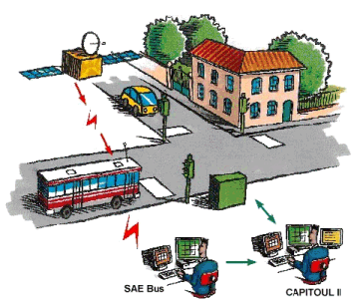

- Service Reliability

Service reliability is ‘keeping the transit vehicle on schedule, with uniform headways and a consistent travel time’. In 2001 Kimple said, ‘Transit service reliability is a multidimensional phenomenon, no single measure that can adequately address service quality”. For public transportation service, schedule reliability is generally a central point in the service level agreement. Unreliable bus service can lead to longer waiting time and traveling time for passengers. However, bus services are born unstable due to many reasons. Generally, buses leave their departure station at regular intervals, namely the headway. But the intervals become irregular with buses traveling along the route. Reasons can be summarized into two aspects, the first of which is the randomness of passengers’ arrival at certain bus stops. When a bus falls behind its schedule, the headway with the preceding bus will become longer while the one with the following bus will become shorter. In other words, this may cause more passengers waiting at the approaching stop then result in more boarding time and make the bus fall further behind. The second reason is variability of travel time between stops due to traffic congestion, signal control and the difference of bus driver’ driving behavior.

2.1 Components of service reliability

The ‘excess waiting time’ is the difference between the actual waiting time of passengers at bus stops and the average waiting time based on the scheduled headway. This excess waiting time for the passengers is the key performance criterion adopted in the UK for buses operating headway-based services (DfT, 2005; TfL, 2007) The ‘excess waiting time’ of the passengers is calculated as follows :

Excess waiting time = Actual average waiting time - Scheduled average waiting time
Where,
Where, Actual headwayi and Scheduled headwayi are time headways

The excess waiting time thus calculated is valid for high frequency services where passengers tend to arrive randomly without knowing the arrival time of the buses. The excess waiting time (EWT) is the extra waiting time borne by passengers over and above the waiting time that might be expected if all the buses on the route ran on time.

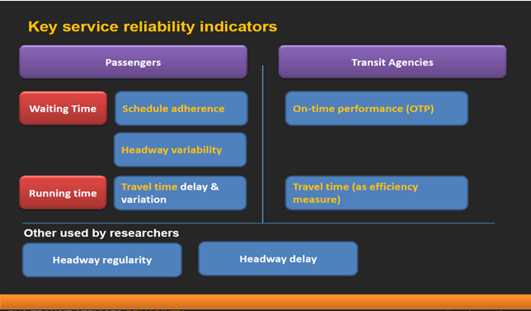

Fig1 To show components of service reliability

2.2 Performance and reliability in Public Transport

• In the past, estimating performance measures was difficult and expensive due to the lack of data (and partially methods)

• Today, Automatic Vehicle Location Systems (AVLS) have overcome this difficulty by providing rich and extensive data

• Traditionally performance has focused on attributes of service
supply (e.g. capacity, passenger loads, frequency, etc.)

• However, a number of studies have focused on the demand side (passengerʼs point of view).

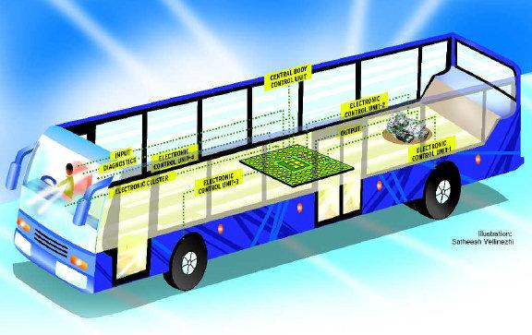

- Automatic Vehicle Location (AVL)

3.1 Introduction of AVL

Automatic Vehicle Location (AVL) systems calculate the real-time location of any vehicle equipped with a Global Positioning Satellite (GPS) receiver. Data are then transmitted to the transit center with use of radio or cellular communications and can be used immediately for daily operations as well as archived for further analysis.

AVL Systems are being introduced increasingly in many major cities around the world to improve the efficiency of our road-based passenger transport systems. Satellite-based location and communication systems, particularly the Global Positioning System (GPS) have been the platform for AVL systems which are now supporting realtime passenger information (RTPI), fleet management and operations (FMOs) and public transport priorities (PTPs), to name three key applications. The common feature of these systems is to provide real time bus location data.

Fig2 to show mechanism component of AVL

As a stand-alone technology, an AVL system can be used to monitor on-time performance. When combined with other technologies, AVL can deliver many benefits in the areas of fleet management, service planning, safety and security, traveler information, fare payment, vehicle component monitoring, and data collection. Since the greatest benefits from AVL are achieved by combining it with other Intelligent Transportation System (ITS) technologies .

The process of real-time on-board bus location can result in a substantial database where the progress of the bus is stored typically on a second-by-second basis. This is necessary for the primary applications such as those listed above (e.g. RTPI, FMO and PTP). In addition, it is clear that such data has an array of ‘secondary’ purposes, including use off-line for improving scheduling efficiency and for automatic performance monitoring, thus reducing or removing the need for manual on-street surveys.

The common thread across all operational systems of this type is the need for efficient data management systems, encompassing all the necessary elements of data collection, processing of the spatio-temporal information at high resolution, data transmission and so on – all according to the system architecture. In some examples this process may be ‘driven’ from the AVL centre or using roadside infrastructure, whilst in others substantial mobile on-bus data management is required.

3.2 Mechanism of AVL

In this intelligent transport system buses are equipped with detection and communication technologies to locate their position in a network and to communicate with the AVL centre. Most of the recent systems are using GPS as the main location technology for their AVL system. In these systems, the AVL centre is at the heart of the system, monitoring buses in the network and assessing their performance. The AVL centre processes the location information collected and produces useful extracts for various applications such as Bus Priority, RTPI and Fleet Management. In the case of RTPI and Fleet management applications, the processed information is used directly, usually without further interaction with buses. However, in the case of bus priority traffic signals, buses will operate within a specified priority architecture. For example, in London, Cardiff and Helsinki, the lateness information is transmitted back to buses (from the AVL centre) so that they can pass the information to the traffic signal controller when requesting priority at a junction. Short range radio is then often used to request such priority. This way of requesting priority to the traffic signal locally is an example of decentralised architecture. In other cases such as Toulouse and Aalborg, the AVL centre directly passes information to the UTC centre without involving buses. This type of communication between the AVL centre and UTC centre is an example of a centralized architecture.

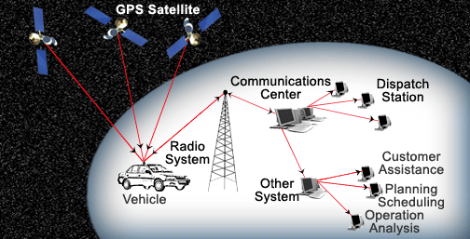
3.3 World’s largest integrated AVL systems - iBus system

The iBus system in London (Fig. 3), is one of the world’s largest integrated AVL systems. It is a comprehensive AVL system based on GPS and supporting technologies (e.g. dead reckoning, Kalman optimisation filter and map matching software) for bus location and the General Packet Radio System (GPRS) for data transfer (Clarke et al., 2007). The system has now been rolled out to every bus and garage in London – that is over 8000 buses and 90 garages. iBus keeps track of London’s buses which send the location of each bus to the AVL centre about every 30 s. This bus location information is then passed onto service controllers to better regulate services to make them more reliable; to the RTPI system to inform passengers; and to buses themselves for priority at traffic signals and data storage for post processing.

Fig 3 gives a simplified overview of iBus system components. Among these, three main components related to bus location data collection and storage are :

- an ‘on-board unit (OBU)’ mounted in each bus (Item L in Fig. 3);
- a ‘data server’ at individual bus garages (Item O);
- a central ‘system server’ located remotely (Item K), which holds the master records of bus routes, their timing points, operating frequencies, as well as information for specific applications, such as the locations of ‘virtual’ detectors for bus priority at traffic signals.
.
3.3.1 How ibus works?

The OBU mounted in each bus is the key component collecting bus location data. It is a computer programmed to receive bus location as well as bus event information from various sources and store them in its memory. In terms of bus location, it receives information every second from a GPS receiver mounted on the roof (Item J) and the odometer and gyroscope.

The System utilizes this information along with optimization and route/map matching algorithms to calculate the buses’ location as accurately as possible. In addition to the bus location, the OBU also records activities of a bus along the route.

For example, it records the opening/closing of doors with time-stamped information from the door sensors (Item G). The bus location information logged in the OBU is automatically uploaded to the data server at the bus garage when vehicles return to the depot using a Wireless Local Area Networking (WLAN). This WLAN uploads data to the Depot host servers with each OBU device and vehicle assigned a unique Media Access Control (MAC) address and Technical Vehicle Number (TVN) for data communications and identification purposes. The location and activities data is then forwarded from these servers to the TfL central server via wide area communications links for post processing, historical storage and management reporting. In addition to bus location data collection, the OBU is also responsible for triggering bus priority at traffic signals.

Fig3 iBus system in London (from Tfl,3006)

- A bus priorty fault detection and performance monitering
- B system data base
- C,H bus priority radio link
- D bus processor (controlled within traffic signal controller)
- E traffic signal controller
- F,N bus detection points
- G bus door sensors
- J GPS receiver
- K central bus server
- L iBIS unit
- M GPS satellitebus garage

When bus is in garage, it is linked to the central system server to send and receive bus priority.
The OBU keeps a record of the priority-defined virtual detection points which are compared with the bus location to trigger priority at each equipped traffic signal. For this priority triggering purpose, the OBU is connected to a transmitter mounted on the roof of each vehicle (Item H); this sends Real-Time Information Group (RTIG)-compliant radio ‘telegrams’ to request bus priority from individual traffic signal ‘controllers’ (Item E) via their aerials (Item C). When buses return to their depots at the end of each ‘block’ of trips, their OBUs are connected to the garage’s data server through the WLAN. This in turn, provides a link to the remote central system server for the purpose of downloading new route and/or detector locations into the OBUs, and to upload the individual bus location/event ‘log’ files. The log files are then consolidated centrally, to provide local databases for users, which are used for information storage, historical analysis, and management reporting. Flowing graph gives the idea about diversity of vehicles in global world

Fig: Modal split in the world

3.3.2. Real-time passenger information

One of the main real time applications of the bus location data available from iBus is to provide real time information on bus service arrivals to passengers. London’s real time passenger information system, known as COUNTDOWN, was operated initially using roadside beacons located along the bus route. Although the system was successful, it only served part of the overall network. With the implementation of iBus, RTPI will be available at 2500 key bus stops in London by 2011 (TfL,2010c). TfL also provide various other means for receiving this information, including: next-stop signage on board, text messagingand the internet (see Fig. 2).

3.3.3. Fleet management and operations (FMOs)

FMO is another real time application of the bus location information available from iBus. In addition to the TfL control centre, the real time location of buses is available to service controllers of respective operators’ garages. There is a provision to display the location of every bus against tabular representation and geographical maps, along with their performance relative to the scheduled frequency or headway for that route, e.g. whether each bus is ‘early’, ‘on-time’, or ‘late’ (as defined in the system). Such information available to the service controller allows him/her to take fleet management actions quickly in the case of disruption in the network.

3.3.4 Bus priority at traffic signals

Another application of iBus is to enhance London’s successful bus priority at traffic signal system. This replaces earlier infrastructure-based detection systems (Hounsell and Shrestha, 2005) used for bus priority at traffic signals. For example,in-road inductive loops or physical road-side beacons with associated vehicle transponders to identify buses on approach were used to trigger priority on the approaches of traffic signals to provide them with a green time extension or recall at the signal. However, these physical infrastructure-based ‘Selective Vehicle Detection’ (SVD) systems are becoming increasingly outdated, as they are relatively expensive to install and maintain, so are no longer being applied to London’s signal junctions (TfL, 2006).
With iBus, SVD is triggered through the use of ‘virtual’ detectors. These locations associated with each signal junction and defined in terms of a set of GPS longitude and latitude coordinates, are programmed onto the OBU of each bus. These bus detector locations are configured in the on-bus computer of iBus equipped buses and have no physical presence – hence their name as ‘virtual detectors’ (Hounsell et al., 2006). The predefined virtual detector coordinates are compared with the dilocation of the bus obtained from the on-bus navigation system to ascertain whether a bus has reached the detection position to trigger a priority request by transmitting a bus priority telegram to the traffic signal controller. Virtual detectors allow much more flexibility in terms of installation and repositioning. They may be used at new junction sites or to replace (or supplement) existing physical SVD detector locations, as they do not require road-side infrastructure changes. iBus is enabling bus priority at traffic signals to be introduced much more widely across London, because of the reduced infrastructure costs associated with ‘virtual’ bus detectors and improved system functionality/benefits. A simple representation of bus priority at traffic signals using iBus is shown in Fig. 3. At present, virtual detectors for priority are only being located where physical detection would have been located. However research (Hounsell et al., 2004) has shown that bus delay savings can sometimes be improved by increasing the number of virtual detectors on a traffic signal approach and thus monitoring the buses progress more closely. For example, a detector upstream of a bus stop and/or at the junction exit can be particularly beneficial in the right circumstances. In addition to the flexibility of virtual detectors to trigger priority at traffic signals, iBus also provides bus performance information relative to other buses serving the route or relative to the timetable the bus is on. With iBus, the control centre has the information of all the buses serving the network. It uses such information to calculate the headway of a bus (relative to other buses on the same route) or the earliness/lateness of the bus relative to the predefined timetable. Such information is available in real time. This provides an opportunity to implement ‘differential priority’ at traffic signals – a strategy where priority is given according to the individual needs of buses, e.g. depending on differing thresholds of regularity or punctuality. This form of priority helps to reduce the impact on other traffic, and leads to more regular and improved journey times for buses overall.

4. Data architecture and post processing applications

In addition to the real time applications described above, iBus stores historic second-by-second information of all the buses in the network. This data is then post-processed for monitoring and reporting purposes, including such data as average
route journey times (Hardy, 2009). Fig. 4 shows two distinct paths of iBus data applications: real time applications and postprocessing applications.

Looking now at the post-processing applications, these are largely driven by user requirements relative to the information available. So, for example, the bus event log files and databases provide a vast repository of operational information collected
by London’s buses, including vehicles’ real-time GPS locations and messages of their interactions with traffic signals, as well as trip journeys times, relative headways, and average speeds on route. Key examples of the current and forthcoming uses of this data include;
- average route journey times (Hardy, 2009) and
- automatic performance monitoring, particularly for
bus punctuality and regularity statistics which have previously relied on manual surveys on-street.

Looking to the future, it is clear that the quantity and detail of the information recorded in the bus log files and central databases lends itself to a variety of other applications, including: improved bus service monitoring, enhanced operational reporting/scheduling, enriched spatio-temporal analysis, dwell time estimation, emission estimation and bus priority surveys. Some of these applications are now described and others are discussed in more detail.

4.1. Improved bus service monitoring

TfL produces a quarterly service performance report (TfL, 2010b) on high-frequency services (representing services with 5 or more buses per hour). This has been based on manual on-street data collection typically at a set of five or six pre-set points automatically using data available in the system. Potentially though, the system contains many more location points which record times, allowing many more timing points to be defined, thereby significantly increasing the sample size for measurements to be taken along a route for the monitoring of average and ‘excess’ passenger waiting times at bus stops. The ‘excess waiting time’ is the difference between the actual waiting time of passengers at bus stops and the average waiting time based on the scheduled headway. This excess waiting time for the passengers is the key performance criterion adopted in the UK for buses operating headway-based services (DfT, 2005; TfL, 2007). The ‘excess waiting time’ of the passengers is calculated as follows (TRG, 1997):

where Actual headwayi and Scheduled headwayi are time headways for bus i.The excess waiting time thus calculated is valid for high frequency services where passengers tend to arrive randomly without knowing the arrival time of the buses. The excess waiting time (EWT) is the extra waiting time borne by passengers over and above the waiting time that might be expected if all the buses on the route ran on time. It reflects the regularity of the service. This is identified as the most important factor for quality of a bus service and its importance is reflected in DfT’s
Webtag (DfT, 2011) by valuing non-working time (‘commuting’ and ‘other’) spent waiting for public transport as two and a half times the ‘commuting’ and ‘other’ values.

4.2. Enhanced operational reporting/scheduling

Historically, TfL has only given passengers an indication of the scheduled journey times e.g. between two given points for a particular service, although actual journey times can vary according to level of traffic congestion and the time of day. Given that iBus holds the second-by-second timing of each vehicle, the iBus data may now be used to calculate actual journey time performance or the ‘run’ times between two pre-determined timing points, e.g. between two bus stops. On a simplistic level, this may be grouped by different time-of-day periods (i.e. morning peak, evening peak, and two inter-peaks) to provide passengers with improved journey time reporting, as well as an indication of their variability – see Fig. 5. Fig. 5 shows the actual weekday average, maximum and minimum journey times (compared to scheduled) between two bus stops on a given London bus route (No. 198) in June 2010. The scheduled journey time between stops for the service is set at 1 min, while the average actual time varies from 0.91 to 1.12 min, depending on the time of day (it is principally a shopping service), with a maximum and minimum of 0.68 and 1.50 min respectively. Taken across the entire route of 48 us stops, this data may be used to improve the run time of vehicles for scheduling purposes, including their variation with the time of day. A similar analysis can be performed for other days of the week, or to analyse journey times for other time periods (e.g. the night-time service). The run times could also be analysed over a longer period of time to review the service performance of a certain route for operational review purposes. This information can be used to help improve bus schedules,
and allow operators to submit more realist schedules for future operations. Where bus services are tendered out to private operators, as is the case in London (where bus operators typically perform against a 5-year Quality Incentive Contract), this
last point is of paramount importance, as operators are rewarded for bus reliability or their adherence to the contracted headway (for high-frequency services) or timetable (for low-frequency services), and it is therefore necessary to have adequate benchmarks for comparison purposes.

4.3. Spatio-temporal analysis

The provision of historic second-by-second GPS location information from each bus allows for the complex spatio-temporal analysis of bus services, including vehicle and driver locations. For example, from time-to-time, it may be necessary to view the performance of individual vehicles. Fig. 6 shows the simplified Northbound and Southbound journeys undertaken by one vehicle on a route north of Central London during 1 weekday in September 2009. On one of the Southbound routes, It can be seen that the driver needed to take a detour around Mornington Crescent Station, which can be used for audit checking (e.g. where operators incur lost mileage), driver and vehicle performance monitoring, and for providing supporting evidence to the emergency services.

4.4. Dwell time estimation

The ability to derive typical dwell times at bus stops from the iBus data has a variety of uses. For example, the dwell time profiles could help TfL to optimise the location of vehicle detectors in providing bus priority through iBus, and provide guidance values to systems like SCOOT or Countdown to improve their performance. Dwell times are also useful generally in public transport operations, traffic management and micro-simulation modelling, by providing an improved understanding of the expected delay of vehicles at bus stops and therefore their impact on other traffic, and help predict more effectively the overall link journey times for both buses and other vehicles. Previous research on dwell times in London (York, 1993) is now largely outdated, due to major changes to the vehicle fleet composition, passenger demand, and road traffic conditions. While other countries have conducted more recent research, these have involved operations on a smaller scale, used different definitions of dwell times, or relied on Automatic Passenger Counter technologies in their estimates, which have yet to be applicable to London. Extracting the dwell time-related data from the iBus databases is not necessarily automatic or straightforward. The database records are not relational so it is not easy to associate when a vehicle has entered the capture zone of a bus stop, and determine when its doors opened and closed, and other associated vehicle stationary times. These three types of events are independently recorded in the bus log files, and logic must be written to associate these records based on their sequence or relative timings. The data required needed to be derived using new computer algorithms, via timestamps of when vehicles recorded these events, as stored in these files.

Among over 35 different record types stored within the bus log file, there are four which may be used individually or collectively to derive dwell time. These are
1. vehicle halt events (either a halt ‘beginning’ or a halt ‘end’);
2. bus stop zone events (either vehicle ‘enters’ or ‘exits’ the capture zone of a bus stop, which is typically defined as 30 or
50 m before and after the site of the bus stop ‘flag’ or pole);
3. door events (when the doors have either ‘opened’ or ‘closed’);
4. detailed GPS second-by-second location, with associated vehicle speed (from the odometer pulses).
Middleware programs have been developed in C++ by the Authors of this paper to convert the raw bus log file data into more meaningful forms, by capturing and comparing the recorded timestamps of when vehicles entered and exited the bus
Mapping of a journey undertaken by a bus.

stop capture zones, halted, opened and closed doors, and/or when the speed remained at zero, and using these to derive the bus stop dwell time durations – see Fig. 7 below. There are many different definitions of what constitutes bus stop dwell times, for example York (1993), DfT (2006), and Robinson (2009). In addition to the time taken for passengers to board and alight (which is included within the door open
and close times), dwell time may also be defined to include other associated vehicle ‘dead’ times (York, 1993), for example when the bus remains stationary while waiting to re-join the traffic flow. These various definitions of dwell may be derived using one or more combinations of the different bus log file events, since these provide the necessary information to calculate the range of stationary or dead time durations at a bus stop.

4.5. Bus performance analysis for bus priority

The provision of bus priority at traffic signals with iBus requires buses to identify when they are at the relevant virtual detection point (VDP) and to send a telegram to each ‘bus processor’ located within each traffic signal controller cabinet on street. The telegram contains various items of data including punctuality information of the bus which the bus has received from the control centre. This telegram information, which is used to request priority, is also stored in the bus processor unit. The punctuality information is categorised into sixteen different groups such as ‘within 1 min of the expected time’, and ‘2 min late’. This level of information is provided to give different levels of priority to the buses depending on their punctuality situation. However, such information can also be used to analyse the performance of the buses in terms of their punctuality along the route.
To carry out such analysis, a survey was carried out in February 2010 by collecting bus processor data from 10 northbound and nine southbound junctions on a bus route in North London. The bus processor data included: Site ID, Date, Time, Input priority, Output priority, Output action, Vehicle number, Movement number, Trigger point and Schedule deviation value.
An example frequency distribution showing the punctuality of southbound buses at three different locations (the start, middle and end of the route) is shown in Fig. 8.
Fig. 8 shows that the profile is flatter towards the end point of the route in comparison to the start. This illustrates how categories taking account of all the junctions in the northbound and southbound directions included in this study are given in Table 2.

Processed iBus data for estimating dwell time information.
The table shows that in average 37% of buses were more than 1 min early and 42% were more than 1 min late. There were 21% of buses within 1 min of the expected time. This punctuality information could be used to ascertain the percentages of buses getting different levels of priority depending on the priority logic, or to design a priority logic within given punctuality constraints. Table 3 provides an example of a possible logic for ‘differential’ bus priority of this sort. If the priority logic given in Table 3 is implemented, based on Table 2 and 11% of buses (buses more than 7 min late) will get the highest priority (level 3). Similarly, 22% of buses will get level 2 priority and 31% will get level 1 priority. The percentage of buses not getting priority (early by more than 1 min) is 34%. In addition, information given in Table 2 could be used to design the priority logic to remain within a constraint. For example, if it is decided that highest level priority should not be given to more than 10% buses, then the criteria for such level should be late by more than 10 min (based on Table 2).

5. AVL data and its flow
Schedule-adherence data records are collected in a summary file on a daily basis. The summary files capture data at the time point level and have the following name format: Date_ADHSUMM.LIS (e.g., 02-APR-2006_ADHSUMM.LIS). They are stored in the network.

5.1 Database Storage
A Microsoft Access Database (CADAVL.MDB) was designed to store the daily summary files that contain the schedule-adherence data. This would allow easy access to and retrieval of the data. Further, an automated process was created to collect and load the data into the database to simplify the data transfer, conversion, and appending processes. This is accomplished by a series of batch files that are scheduled to run on a daily basis, so that the database always contains the latest schedule-adherence data. Below are the five batch files used in this process. In addition, the computerized code of these batch Files as well as the time when they are scheduled to run are provided in Appendix A.

CADAVL_FILE.BAT – This batch process copies the current summary file from the Z: network drive to the C: local drive and renames the file to ADHSUMM.TXT. This file will be loaded into the MS Access database. If this batch process fails, an error log is generated. Refer to Appendix A for information on the computerized code of this batch file.
CADAVL_MACRO.BAT - This batch process calls a Macro inside the MS Access database that formats and loads the summary file into the database. If this batch process fails, an error log is generated. Refer to Appendix A for information on the computerized code of this batch file.
CADAVL_BKUP.BAT - This batch process backs up the database located in the local drive to a folder in the network. M:\CADAVL_Database. The M: drive is located at: \\fileserver1\planning. Refer to Appendix A for information on the computerized code of this batch file.
CADAVL_BKUP1.BAT - This batch process is similar to the previous one. It provides an additional back up in case of data failure or corruption. The location of the database is M:\CADAVLData_Bkup. Refer to Appendix A for information on the computerized code of this batch file.
DEL_ADHSUMM.BAT - This batch process is used as data clean up. It deletes the ADHSUMM.TXT. Refer to Appendix A for information on the computerized code of this batch file.

In summary, the five batch processes copy, format, and append schedule-adherence data into the database and back up the database to the network. Appendix B depicts the data flow diagram of the data transfer and storage process.

5.2 Mapping the Network Drive

As stated previously, the MS Access database is located in the M: drive. Therefore, the network folder \\fileserver1\planning needs to be mapped to the M: drive. The following couple of pictures show the Map Network Drive Tool in My Computer and how to map the network drive.
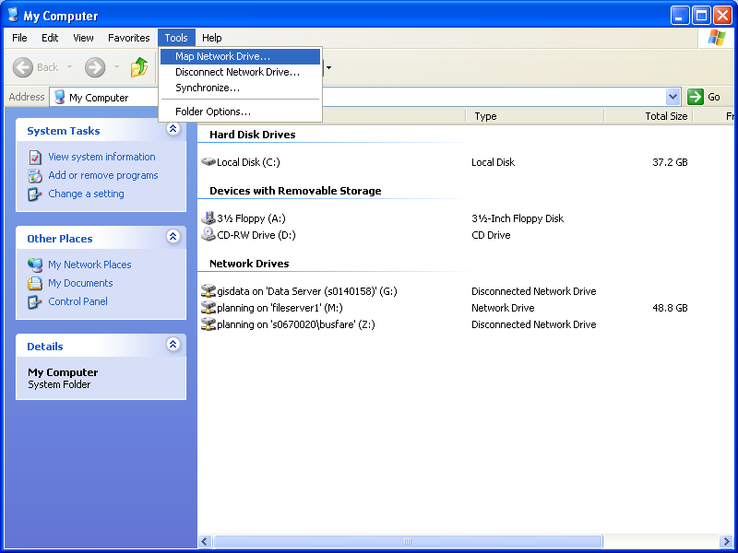
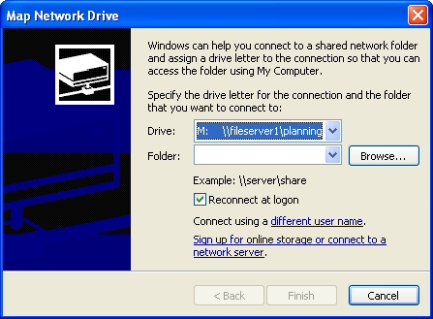

It is important to mention that the database in M:\CADAVL_Database can be accessed through the network. Therefore, it has been set up to be read-only to protect the accuracy of the data and avoid any potential problems. If the users open the database, they will see the following message.

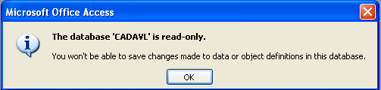

This will prevent users from overwriting the database. However, if users need to perform more sophisticated data analysis that requires modifying the database, they can copy the database in M:\CADAVLData_Bkup to their local drive.

5.3 Database Description
The CADAVL database contains a series of tables, queries, reports, and a macro. The main table is ADHSUM (Adherence Summary), which stores all the schedule-adherence summary data from the CAD/AVL system. The picture below depicts the ADSUM table (highlighted). Other tables include the Timepoints, Data_Wkd, Data_Sat, and Data_Sun. Section 3 discusses the uses of these tables in the on-time performance process.

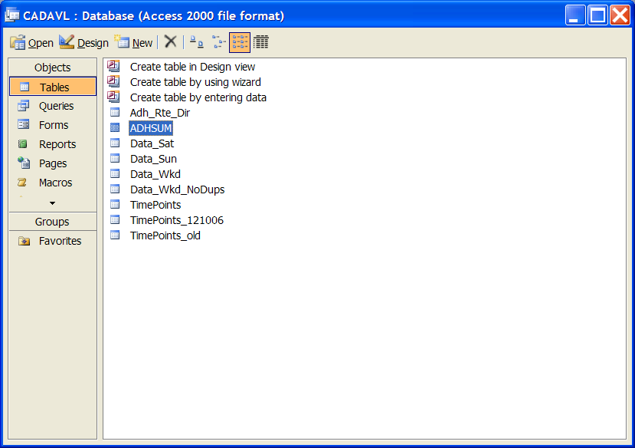

5.3.1 ADHSUM Table
The following picture is a snapshot of the CAD/AVL summary data (15-jan-2007_adhsumm.lis). The data is formatted and parsed before is loaded into the Access database.
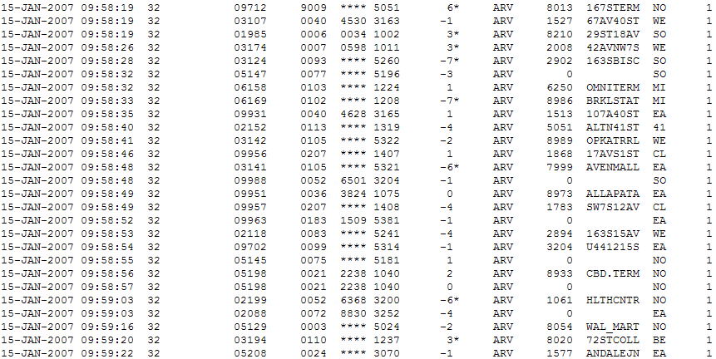

The ADHSUM table stores all the raw schedule-adherence data collected by the CAD/AVL system. It contains 16 fields that capture all the data records from the summary file. The following table shows the data fields, associate data types, and the description of all the fields in the ADHSUM table, as designed in MS Access database.

Fields | Data Type | Description
ID | AutoNumber | Unique Record Identifier
Date | Date/Time | Date
Time | Date/Time | Time
Code | Number | CAD/AVL Code
Veh | Text | Vehicle Number
IB_OB | Number | Inbound or Outbound Code
Route | Number | Route Number
Emp | Text | Employee Number
Run | Number | Run Number
Adh | Number | Schedule Adherence
Star | Text | Vehicles Early or Late¹
Arr | Text | Arrive Code
Node | Number | Time Point Number
TP | Text | Time Point
DIR | Text | Direction²
DOW | Number | Day of Week³

¹ An asterisk is generated for vehicles that are not on-time, as per the CAD/AVL system. Schedule Adherence is more than 2 minutes early or less than -5 minutes late.
² This field indicates the direction of travel. EA = East Bound, WE = West Bound, NO = North Bound, and SO = South Bound.
³ The DOW field has been coded as follows: Monday = 1, Tuesday = 2, and so forth.

5.3.2 Queries
There are a number of queries in the database that provide additional functionality, see picture below. Some were created to generate reports, while others are used to performed data checks or to export data. For instance, the Sch_Adh_Excel_Route_DOW query retrieves data from the ADHSUM table by date, route, and DOW. This can be exported to Excel for more detailed data analysis. The ADHSUM_Dates query displays the available dates with schedule-adherence data, as they were loaded into the database. The query is sorted in ascending order. Records_per_Date_less_5000 shows the dates with low number of records (e.g., less than 5,000). This can be used to detect data collection problems with the CAD/AVL system. Further, the 5,000 threshold can be easily modified by opening g the query in design mode.
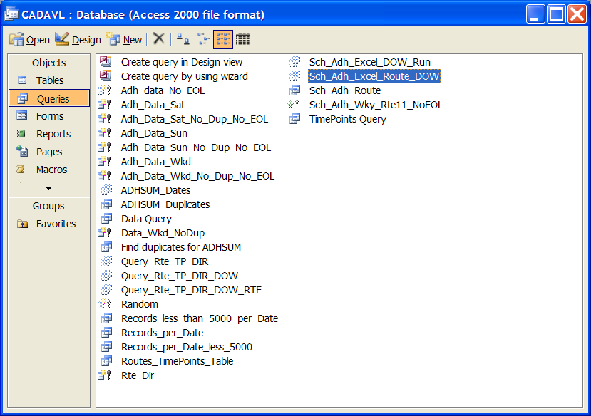
In some queries, date parameters are required. For instance, in the pictures below a query is performed from 01/22/2007 to 01/26/2007. Note that the dates are in the MM/DD/YYYY format. Where MM is month, DD is day, and YYYY is Year.
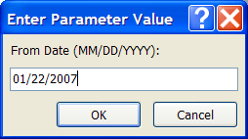

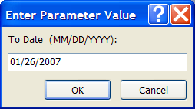
Similarly, the following window is used to enter the route number.
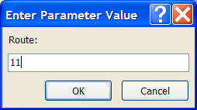
The following windows were used to enter the days of week (DOW). In this case, the query is from Monday (1) to Friday (5).
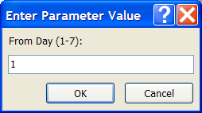

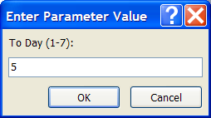

The result of the previous query is depicted below.

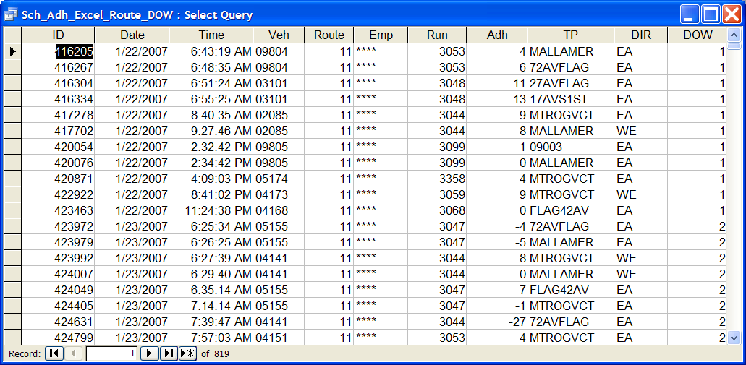
Similar to the Sch_Adh_Excel_Route_DOW query, the Sch_Adh_Excel_DOW_Run allows retrieving data by date, route, DOW, and by run.
Another useful query is ADHSUM_Dates, which allows seeing all the dates of the data stored in the database. This query can be used before running other queries and reports.
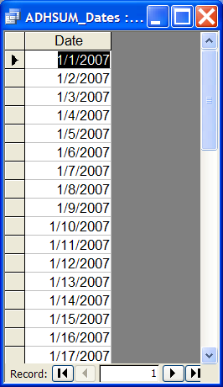
To see how the queries were created and the parameters used, right click a query and select Design View. Below is Query_Rte_TP_DIR query. Note that Route and DIR are Sorted in Ascending Order, Route and TP are filtered (Is Not Null), and Date and Time include the From To parameters.
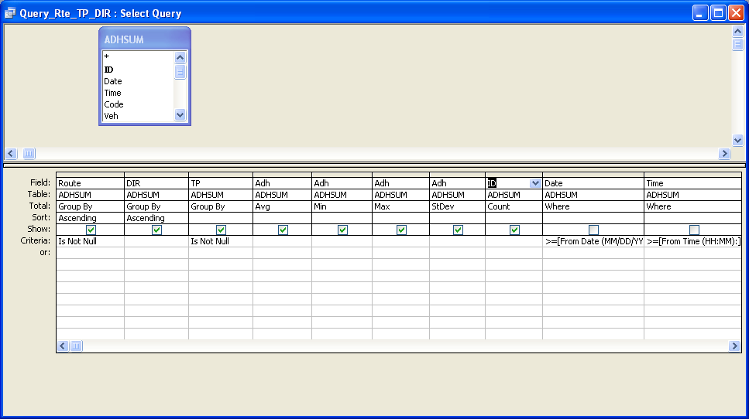
5.3.3 Reports
The two reports are: Query_SchAdh_DOW and Query_SchAdh. Both reports provide similar information. However, the Query_SchAdh_DOW report can be used to create a report for a particular day of week in addition to a date and time range. These reports also allow entering the time of day parameters, where HH are hours and MM are minutes.
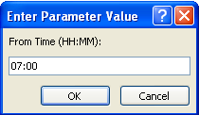
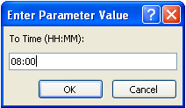
Note that if you want to create a report for the whole day, you need to enter 00:00 (From Time) and 23:59 (To Time). If you use 24:00 instead the system can not differentiate from 00:00. So the message below will appear alerting the user that the expression is incorrect or too complex.
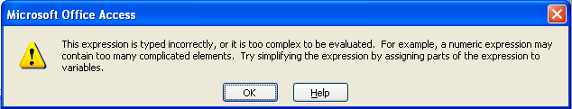
The Reports provide the following summary information: Route, Time Point, Direction, Average, Minimum, and Maximum Schedule Deviation as well as a total Count of the number of records. The reports are sorted by Route and Direction. Further, the reports are filtered, so that only record with exiting Route and Time Points values are considered.
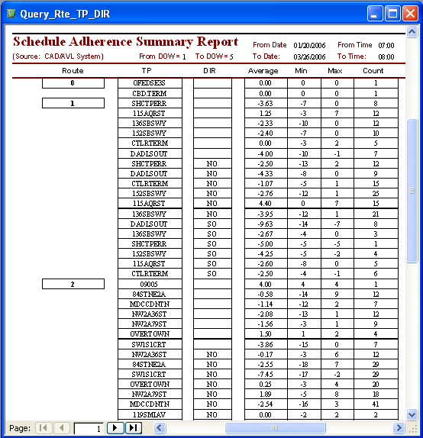

- .Conclusion

Implementation of automatic vechile location system (AVL) technology to increase service reliability is good concept in this gadget based scenario , use of global positioning system makes the AVL more efficient as it provide running position of the vehicle by providing data sets . Now everybody is having smart phones which may have tracking applications , AVL will provide fast tracking application with real time positions.
AVL needs a lots of initial investments, therefore, it is not implemented in developing countries . Use of gadgets those are economical and reliable can change the recent transportation system to an intelligent transportation system.

Appendix A
CAD/AVL Batch Files and Scheduled Tasks

Task 1) Copy Summary files - Scheduled to Run Daily at 2:00 AM
:: CADAVL.bat
:: Copies CAD/AVL Summary File as ADHSUMM.TXT into the Database Folder.
:: The data will be appended to the CAD/AVL MS Access database.
::
@echo off
REM set datevar=%date:~4,2%/%date:~7,2%/%date:~12,2%
set dvar=%date:~7,2%
set mvar=%date:~4,2%
set yvar=%date:~10,4%
if "%mvar%"=="01" set new_mvar=JAN
if "%mvar%"=="02" set new_mvar=FEB
if "%mvar%"=="03" set new_mvar=MAR
if "%mvar%"=="04" set new_mvar=APR
if "%mvar%"=="05" set new_mvar=MAY
if "%mvar%"=="06" set new_mvar=JUN
if "%mvar%"=="07" set new_mvar=JUL
if "%mvar%"=="08" set new_mvar=AUG
if "%mvar%"=="09" set new_mvar=SEP
if "%mvar%"=="10" set new_mvar=OCT
if "%mvar%"=="11" set new_mvar=NOV
if "%mvar%"=="12" set new_mvar=DEC
set cur_file=%dvar%-%new_mvar%-%yvar%_ADHSUMM.LIS
IF NOT EXIST Z:\%cur_file% GOTO ERROR
copy /V /Y Z:\%cur_file% ADHSUMM.TXT
GOTO END
:ERROR
echo %date% >> FilesNotLoaded.log
:END
Echo.
Task 2) Run Access Macro - Scheduled to Run Daily at 2:15 AM
:: CADAVL_MACRO.bat
:: Run the MS Access Macro when ADHSUMM.TXT exists.
::
@echo off
IF NOT EXIST ADHSUMM.TXT GOTO ERROR
"C:\Program Files\Microsoft Office\OFFICE11\msaccess.exe" /nostartup C:\CADAVLData\CADAVL.MDB /x ImpAVLData
GOTO END
:ERROR
echo %date% >> MacroFailed.log
:END
Echo.
Task 3) Data Back up 1 - Scheduled to Run Daily at 2:30 AM
:: CADAVL_BKUP.BAT
:: Backs up the CADAVL Database to M:\CADAVLData_Bkup
::
@echo off
IF NOT EXIST M:\CADAVLData_Bkup\CADAVL.MDB GOTO NEWFILE
del /F M:\CADAVLData_Bkup\CADAVL.MDB
:NEWFILE
copy /V /Y C:\CADAVLData\CADAVL.MDB M:\CADAVLData_Bkup\CADAVL.MDB
Echo.
Task 4) Data Back up 2 - Scheduled to Run Daily at 2:45 AM
:: CADAVL_BKUP1.BAT
:: Copies a Read Only CADAVL Database to M:\CADAVL_Database
::
@echo off
IF NOT EXIST M:\CADAVL_Database\CADAVL.MDB GOTO NEWFILE
del /F M:\CADAVL_Database\CADAVL.MDB
:NEWFILE
copy /V /Y C:\CADAVLData\CADAVL.MDB M:\CADAVL_Database\CADAVL.MDB
attrib +R M:\CADAVL_Database\CADAVL.MDB
Echo.
Task 5) Data Clean up - Scheduled to Run Daily at 3:00 AM
:: DEL_ADHSUMM.bat
:: Delete ADHSUMM.TXT file after data has been loaded into the Database.
::
@echo off
IF NOT EXIST C:\CADAVLData\ADHSUMM.TXT GOTO END
del C:\CADAVLData\ADHSUMM.TXT
:END
Echo.

References

1. Kopp, J.C., J.A. Moriarty, and M.E. Pitstick, Transit attractiveness - Systematic approach to transit
performance measurement. Transit: Management, Maintenance, Technology and Planning, 2006
(1986): p. 11-20.!
2. Ceder, A., Y. Le Net, and C. Coriat, Measuring Public Transport Connectivity Performance Applied
in Auckland, New Zealand. Transportation Research Record, 2009 (2111): p. 139-147.!
3. Nökel, K. and M. Bundschuh, Robust Transfers: Transit Timetable Reliability from the Passenger
Perspective, 2006, PTV AG: Karlsruhe.!
4. Kittelson and Associates, et al., A guidebook for developing a transit performance- measurement
system. TCRP Report 88, ed. K. Associates 2003: Transportation Research Board.!
5. Turnquist, M. and S. Blume, Evaluating potential effectiveness of headway control strategies for
transit systems. Transportation Research Record, 1980. 746: p. 25-29.!
6. Abkowitz, M.D.S.; Waksam, R.; Englisher, L.; Wilson, N., Transit Service Reliability, in TSC Urban
and Regional Research Series 1978, U.S. Department of Transportation (DOT): Cambridge.!
7. Levinson, H.S., Supervision strategies for improved reliability of bus routes. Synthesis of transit
practice NCTRP 15. 1991, Washington, DC: Transportation Research Board.!
8. Kimpel, T.J., et al., Time Point-Level Analysis of Passenger Demand and Transit Service
Reliability, 2000, Portland, Oregon.!
Glasgow City Council, 2009. Downloadable from <http://www.glasgow.gov.uk/NR/rdonlyres/160FA4CB-ACC3-4F35-922D-471C3502617D/0/
TheBusInformationandSignallingSystem.pdf> (accessed March 2009).
Hardy, N., 2009. iBus benefits realisation workstream: method and progress to date. Proc. 16th ITS World Congress, Stockholm.
Helsinki Urban Traffic Control, 2003. Helsinki Public Transport Signal Priority and Passenger Information. Online. <http://www.hel2.fi/liikenteenohjaus/eng/
pt_telematics.asp> (accessed March 2009).
Hill, R., Bretherton, D., Maxwell, A., 2001. Real time passenger information and bus priority system in cardiff – development and bus priority trial. Proc. 8th
World Congress on Intelligent Transport Systems, Sydney.
Hounsell, N.B., McLeod, F.N., Shrestha, B.P., 2004. Bus priority at traffic signals: investigating the options. Proc. 12th International Conference on Road Traffic
Information and Control, IEE London.
Hounsell, N.B., Shrestha, B.P., 2005. AVL based bus priority at traffic signals: a review and case study of architectures. Eur. J. Transp. Infrastruct. Res. (1), 13–
29.
Hounsell, N.B., Wall, G.T., 2002. Examples of new intelligent transportation systems applications in Europe to improve bus services. Proc. 2002 Annual
Meeting of Transportation Research Board, Washington.

